12、Admission records of burn department：

China-Cambodia First Hospital

Admission records

Name: Section: Bed No.: Hospitalization number: Ward:

Name: Occupation:

Gender: Work unit:

Age: Address:

Marriage: history: reliability:

Place of birth: time of admission: year Day month

Nationality: Recording time: year Day month

Disease history

Main complaint: cause of burn

Burn date year month day hour burn-to-hospital time day hour

Current medical history: (including pre-hospital treatment)

Past history:

Personal history:

Family history:

body inspection and inspection

T ℃ P Times / minutes R Times / minutes BP mmHg

General situation: mind growth：Normal bad Nutrition: good secondary bad (body) weight kg

Head and neck:

Chest:

Abdomen:

Limbs:

Perineal:

Special site: respiratory tract injury: suspicious none yes Combined injuries ：

eye： ear： oral cavity： other：

Wound examination：

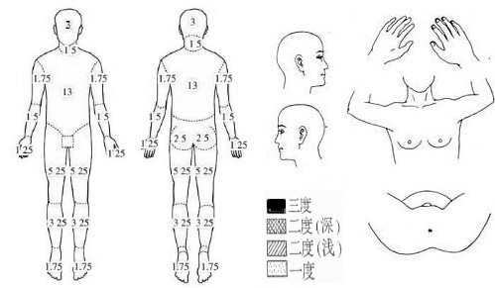

Calculation of body Surface area by Nine method in China：

|  |  |  |  |  |
| --- | --- | --- | --- | --- |
| Ministry Position | | Surface product% | | |
| head | hair | 3% | Unilateral area | One-sided half |
| face | 3% |
| neck | 3% |
| both upper extremities | Upper arms | 7% | 3.5% | 1.75% |
| Bothforearms | 6% | 3% | 1.5% |
| hands | 5% | 2.5% | 1.25% |
| trunk | Front | 13% |  |  |
| Back | 13% |
| perineum | 1% |
| Buttocks and lower extremities | Double Hip | 5% | 2.5% |  |
| Both thighs | 21% | 10.5% | 5.25% |
| Both legs | 13% | 6.5% | 3.25% |
| Bipedal | 7% | 3.5% | 1.75% |

|  |  |  |
| --- | --- | --- |
| position | Level two | Level three |
| head | % | % |
| neck | % | % |
| Body | Front % | % |
| back % | % |
| perineum | % | % |
| both upper extremities | Upper arm % | % |
| forearm % | % |
| hand % | % |
| buttocks  And lower extremities. | buttocks % | % |
| thigh % | % |
| shank % | % |
| foot % | % |

|  |
| --- |
| Area calculation for children under 12 years of age Head and neck = 9 (12-age)  Lower limb = 46-(12-age)  Same as above |

Preliminary diagnosis: total burn area %

Shallow second degree %

Deep second degree %

third-degree %

Signed by the physician:

year month day hour min

Admission diagnosis:

Signature of the doctor:

year month day hour min